SRS for TalentBox

Functionalities
All have defined access and who changes occurs
Role-
- Admin
- Users
Admin
- Dashboard show with limited access
- See applicants and crud operation
- Also change status
- Also send invitation to applicant or email
Users -applicants
- See applicant form
- See status
Header
- Left side
  - Logo
  - Breadcrumb
- Right side
- Profile -> With dropdown
change Password- >page
Logout->Button
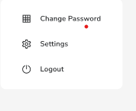
Dashboard -> page
- Dashboard ->label
- Cards
1nd card
    - Total applicants
    - yesterday applicants
2rd card
- Applicants by status
3rd card
Applicant by referrals
1st chart
Chart by months status on baar

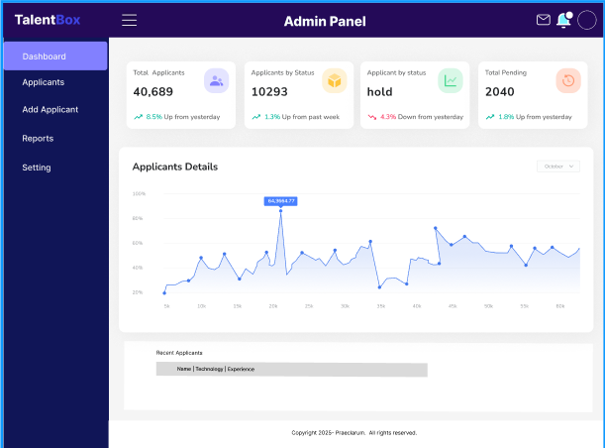

Inbox/ Email -> page
1.Inbox -> label
2.functionalities
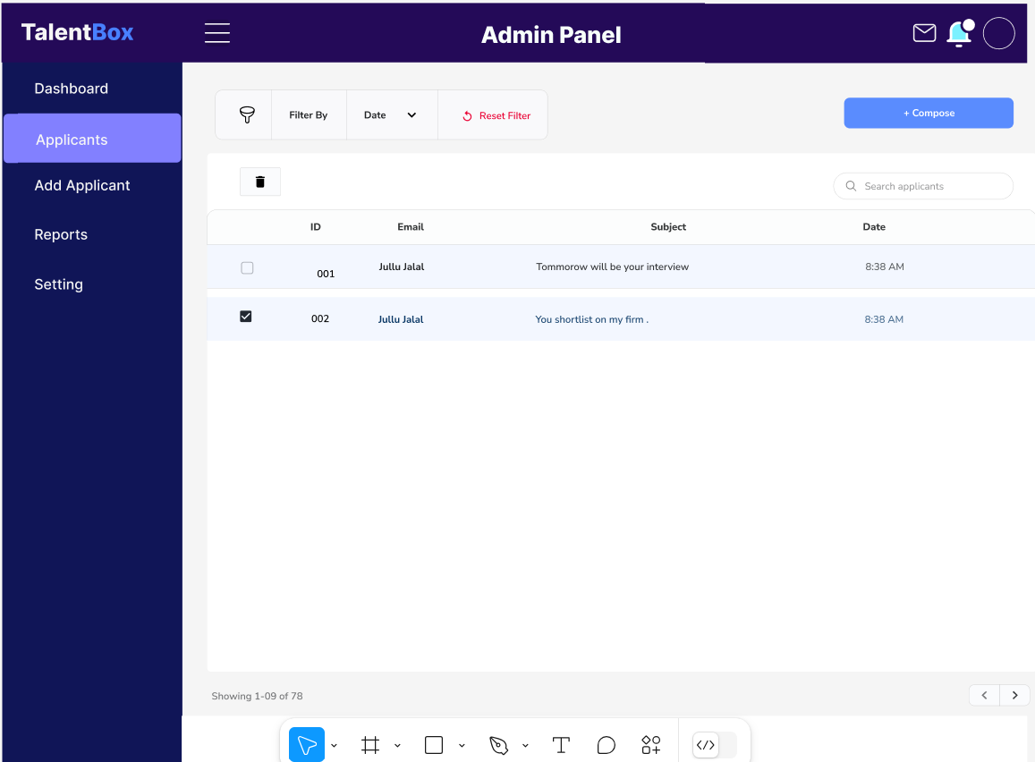
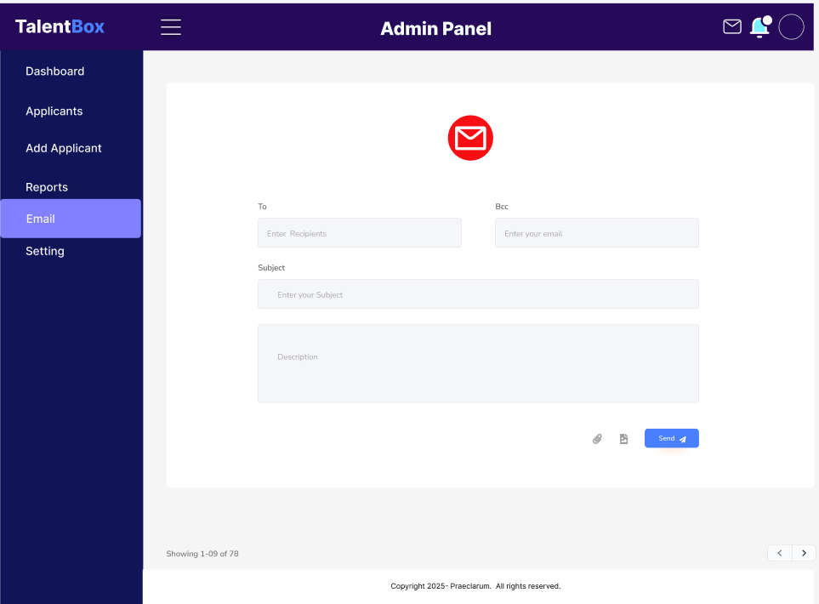
- Show email
Applicant Table -> page
right side
- Add new applicant -> button -> page
- Export on excel,pdf
Search
- Searchbox – from database
- Name auto complete
- Technology
- Experience
- Date
- On table header

s.no: | Name | Technology | Experience | Status | Operation | date | Comment
1 | Op | Reactjs | 0 | Default | Edit |View|Update | 20/12/2024 | Feedback |Email

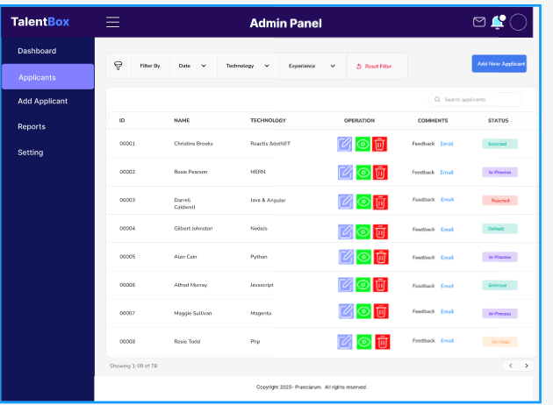
Operation-> button
- Edit|Update |view | feedback| email-> 3 page
Status -> drawer
Add feedback by Hr after interview
Status-
  - Selected
  - On Hold
  - Rejected
  - In Process
  - Default
comments
  - Feedback
  - comments

Reports ->page
1.Visitors – by referred
  - Indeed
  - Google
  - Employee
  - Linkedin
  - Naukari
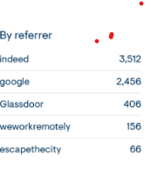
3.Onboarding specialist
- Applications -> progressbar - > with number
- Screened -> progressbar -> with number
- 1st interview -> progressbar-> with number
- 2nd interview -> progressbar -> with number
- On-hold

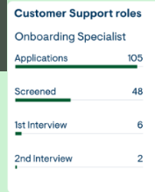
Applicant Form ->page
- On form input field
- Application no#205->auto generate,hidden,disabled
- Firstname
- Middle name
- Lastname
- Phonenumber,
- Whatsapp
- Email -
- Gender- radio button
- Dob - calender
- Qualification ->dropdown
  - Undergraduate,graduate,12^{th,}postgraduate,underpostgraduate
- Degree name> enter
- Passing year -> dropdown
- Current location,
- City,state,pincode,country
- Applied for skills ->dropdown
        - Reactjs ,mern,mean,node ,react+node,dotNet,angular, java,other
- Cv/resume->file upload
- Total experience
- Relevant skill experience
- Other experience
- Javascript rate 4/10
- Current pkg
- Expected pkg
- Notice period
- negotiation able
- Ready for wfo-> yes/no
- Work preference -> remote , onsite, hybrid
- About us /any comment->text area
- Submit- cancel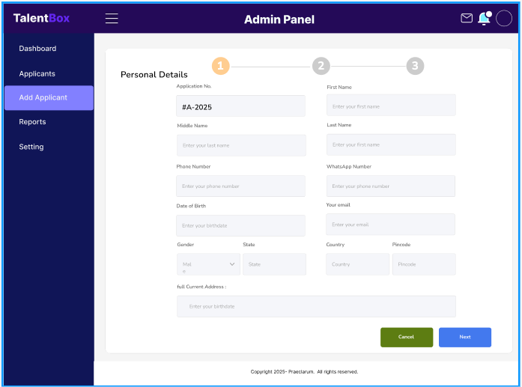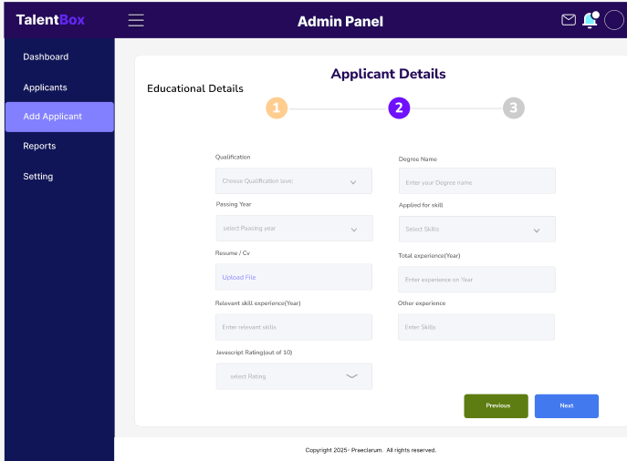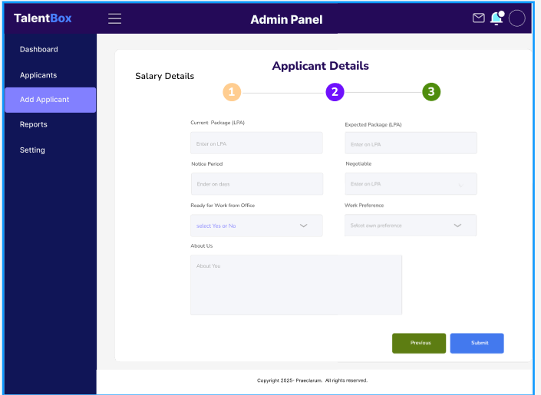

Masters
- Dropdown list of – where we do crud operation with dropdown menu list
  - Passing year,
  - skills

Signup->page
- Fullname
- Email
- Password
- role
- Submit | cancel
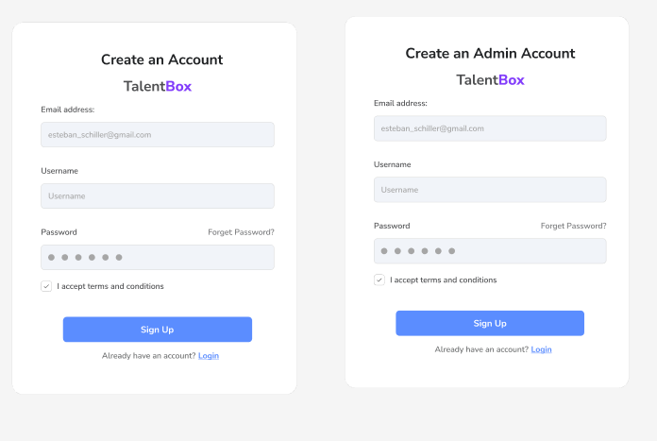
SignIn ->page
- Email
- Password
- Button
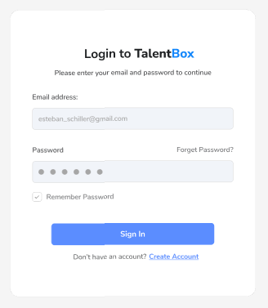

Forgot Password –page
Using email
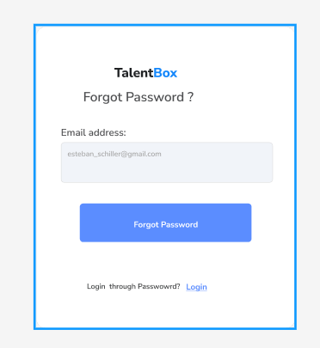

Changed password -page
Using old password
- Old password field
- New password
- Confirm password
- Button |cancel
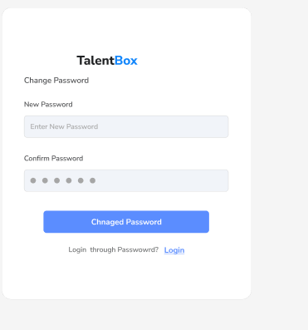

Application technology Technology
- ReactJS – frontend
- NodeJs
- Express- routing
- Mongodb-database
- Tailwind css and css
- AntDesign,Daisy Ui ,material ui

